Chicago-coffee-service project pictures

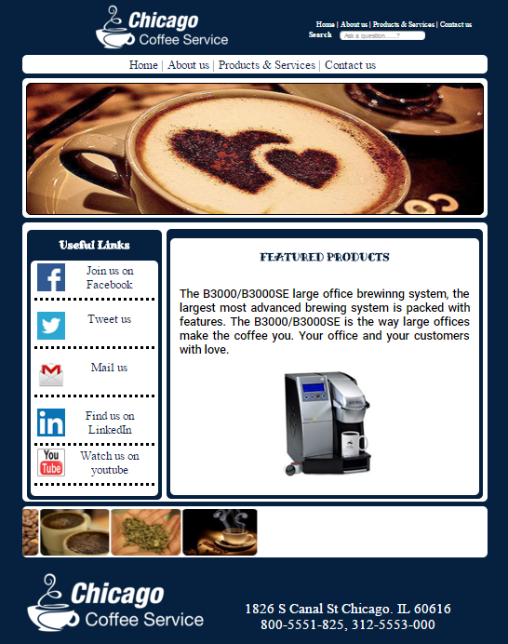

Figure 1: Home page

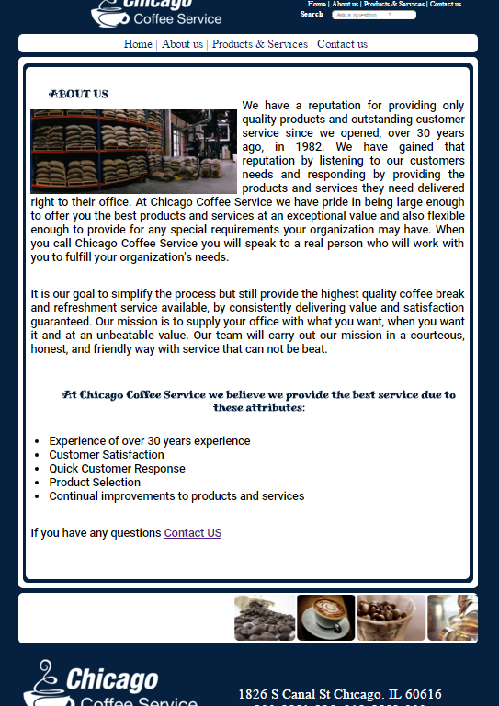

Figure 2: About us

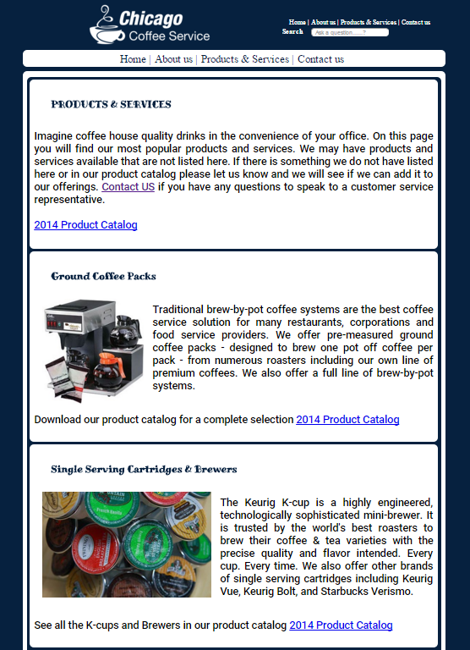

Figure 3: Products and services (part 1)

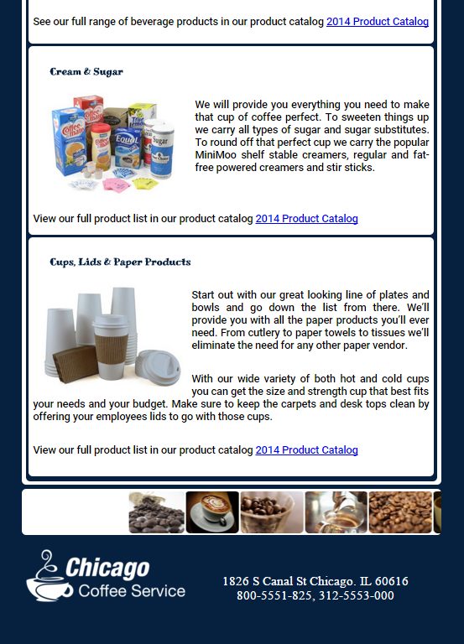

Figure 4: Products and services (part 2)

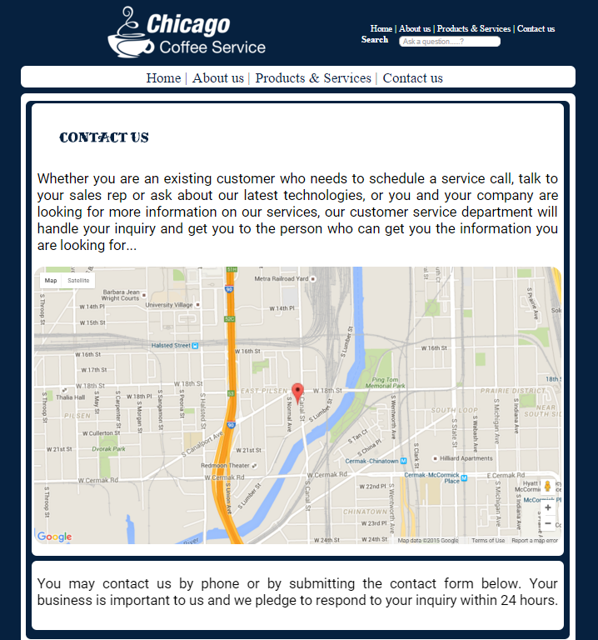

Figure 5: Contact us (part 1)



Figure 6: Contact us (part 2)